Complete GitHub + Jenkins Integration Notes
This document explains complete GitHub workflow from installation to Jenkins integration. It includes theory + practical commands used in real-time company projects.

1. Introduction to Git and GitHub
Git is a version control system used to track source code changes. GitHub is a cloud platform used to store repositories and collaborate with teams.
- Git helps maintain project history.
- GitHub helps developers collaborate together.
- Feature branches are used for development.
- Pull Requests are used for code review.

2. Install Git
Git must be installed before starting project version control.
- Download Git from: https://git-scm.com/downloads
- Install Git using default settings.
- Verify installation using command below.

3. Verify Git Installation
Open Command Prompt and execute commands.
- git --version
- git config --global user.name "Your Name"
- git config --global user.email "yourmail@gmail.com"

4. Create GitHub Repository
Repository is used to store project code in GitHub cloud.
- Login to GitHub
- Click New Repository
- Enter repository name
- Select Public
- Click Create Repository

5. Create Local Project
Create local automation project in your machine.

6. Initialize Git Repository
Initialize local Git repository.
- git init
- git status

7. First Commit Flow
Commit initial project code into local repository.
- git add .
- git commit -m "Initial project setup"

8. Connect Local Project with GitHub
Link local repository with remote GitHub repository.
- git remote add origin https://github.com/username/playwright-project.git
- git branch -M main
- git push -u origin main

9. Important Git Commands
Most commonly used Git commands in real projects.
- git clone <repo-url>
- git status
- git log
- git branch
- git checkout branch-name
- git checkout -b feature/login
- git add .
- git commit -m "message"
- git pull origin main
- git push origin main
- git fetch
- git merge branch-name
- git rebase main

10. Create Feature Branch Workflow
Automation QA should never directly work on main branch.
- git checkout main
- git pull origin main
- git checkout -b feature/login-page
- git status
- git add .
- git commit -m "Added login feature"
- git push -u origin feature/login-page

11. Two Branch Flow Example
Example using two feature branches in same project.
- Branch 1: feature/login-page
- Branch 2: feature/dashboard-page
- QA 1 works on Login module
- QA 2 works on Dashboard module
- Both raise Pull Requests separately

12. Pull Request Flow
After pushing feature branch, Pull Request is created.
- Open GitHub repository
- Click Compare & Pull Request
- Review code changes
- Approve Pull Request
- Merge feature branch into main

13. Pull Latest Code
Always pull latest code before starting work.
- git checkout main
- git pull origin main

14. Git Checkout Command
Checkout command is used to switch branches.
- git checkout main
- git checkout feature/login-page

15. Git Rebase Command
Rebase helps maintain clean commit history.
- git checkout feature/login-page
- git fetch origin
- git rebase origin main

16. Resolve Merge Conflict
Conflicts occur when same file is modified in multiple branches.
- Open conflicted file
- Remove conflict markers <<<>>>
- git add .
- git rebase --continue

17. Jenkins Introduction
Jenkins is CI/CD tool used for automation execution.
- Jenkins automates build process
- Jenkins integrates with GitHub
- Pipeline jobs execute automation

18. Install Jenkins
Install Jenkins in local machine.
- Download Jenkins from official website
- Install Java first
- Install Jenkins
- Open http://localhost:8080

19. Configure Jenkins
Basic Jenkins configuration after installation.
- Unlock Jenkins using admin password
- Install Suggested Plugins
- Create Admin User

20. Install Required Jenkins Plugins
Plugins required for GitHub integration.
- Git Plugin
- GitHub Plugin
- Pipeline Plugin
- NodeJS Plugin
- HTML Publisher plugin
- Allure Jenkins Plugin

21. Configure Jenkins Tools
Configure Git and NodeJS inside Jenkins.
- Manage Jenkins → Tools
- Configure Git
- Configure NodeJS

22. Create Jenkins Pipeline Job
Create pipeline job for automation execution.
- Click New Item
- Select Pipeline -- Frestyle
- Enter Job Name --- any examplpe--(PlaywrightAtomation_CI)
- Source code management-Git
- Provide GitHub Repository URL- https://github.com/junebatch01nrd-blip/PlaywrightAutomationJuneBatch01.git
- Select Branch: */main
- Triggers- PollSCM -- H/5 * * * *
- Build Steps- select excecute window batch command

Screenshot config….
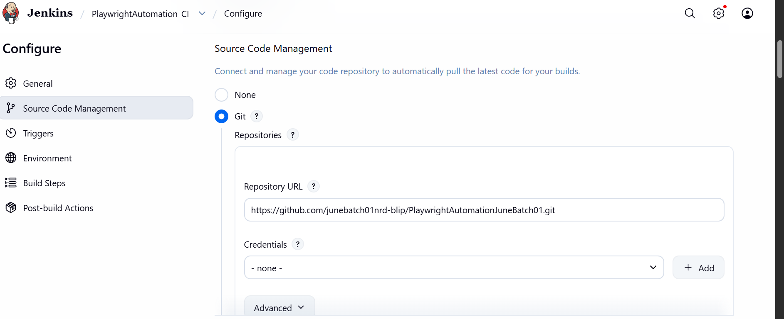

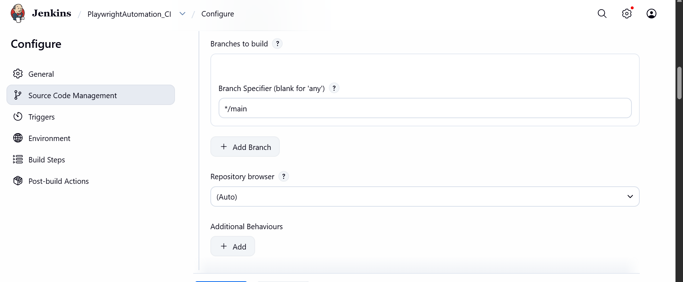

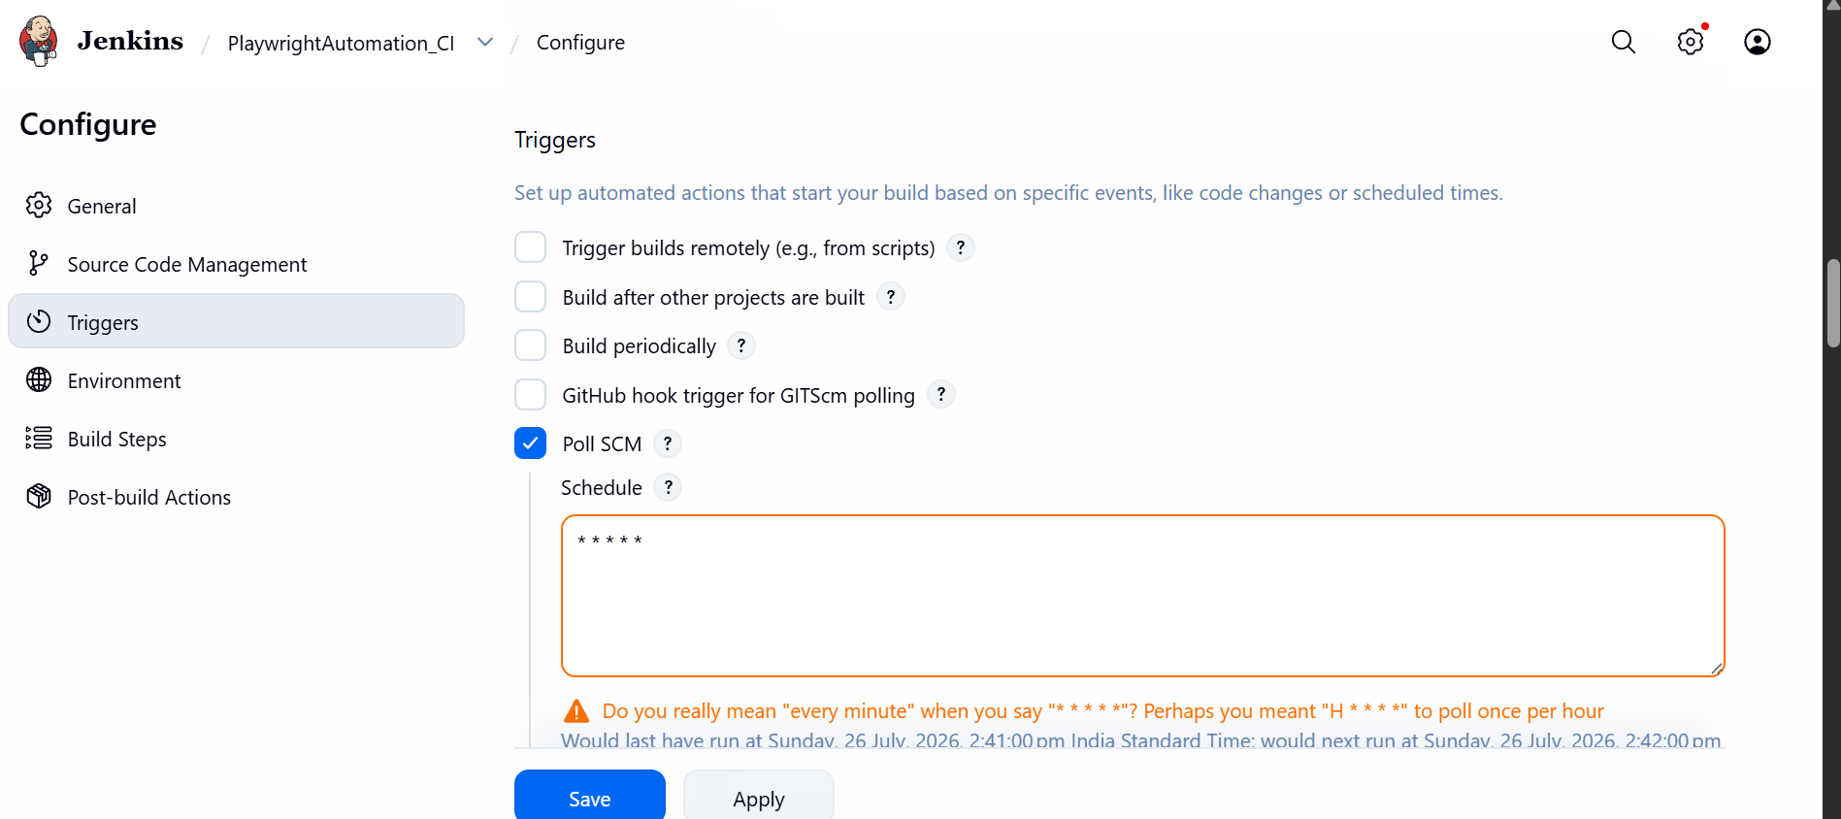

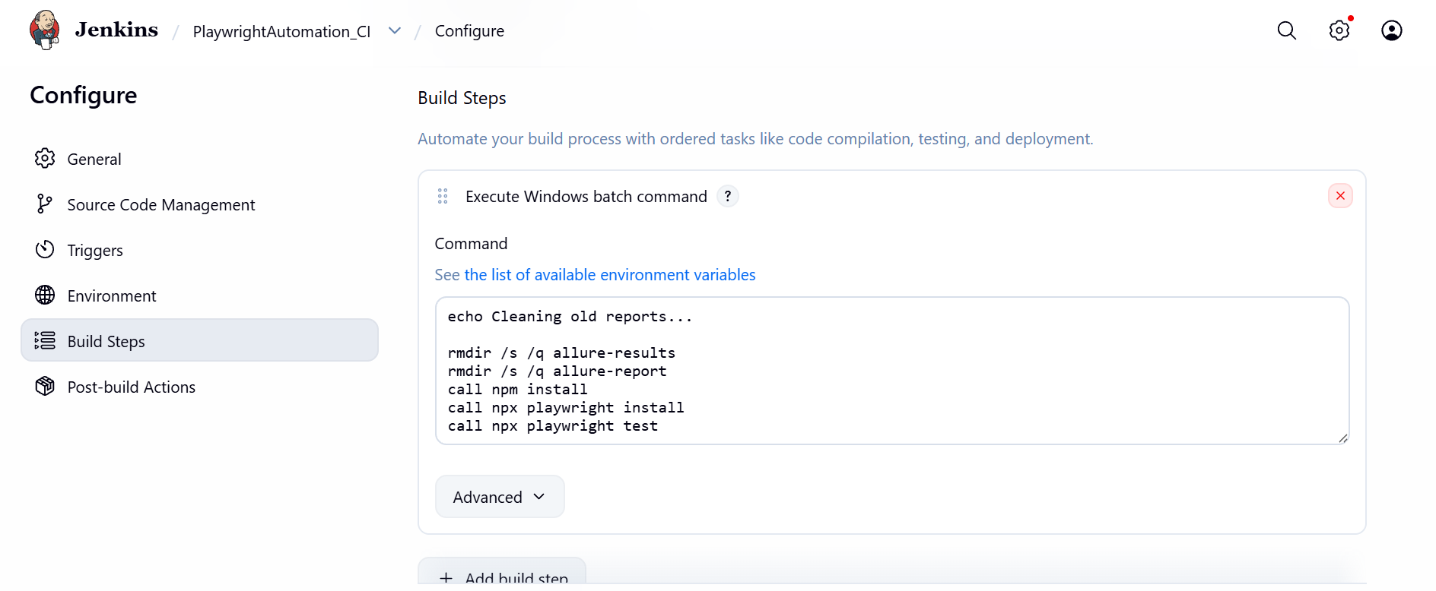

Add Allure reporting and playwright HTML reporting in Jenkins-
How to resolve jenkins content visualization policy

Steps -
Download Allure Jenkins Plugin - Settings-Manage-plugins
Settings-Manage-Tools - Add Allure Commandline
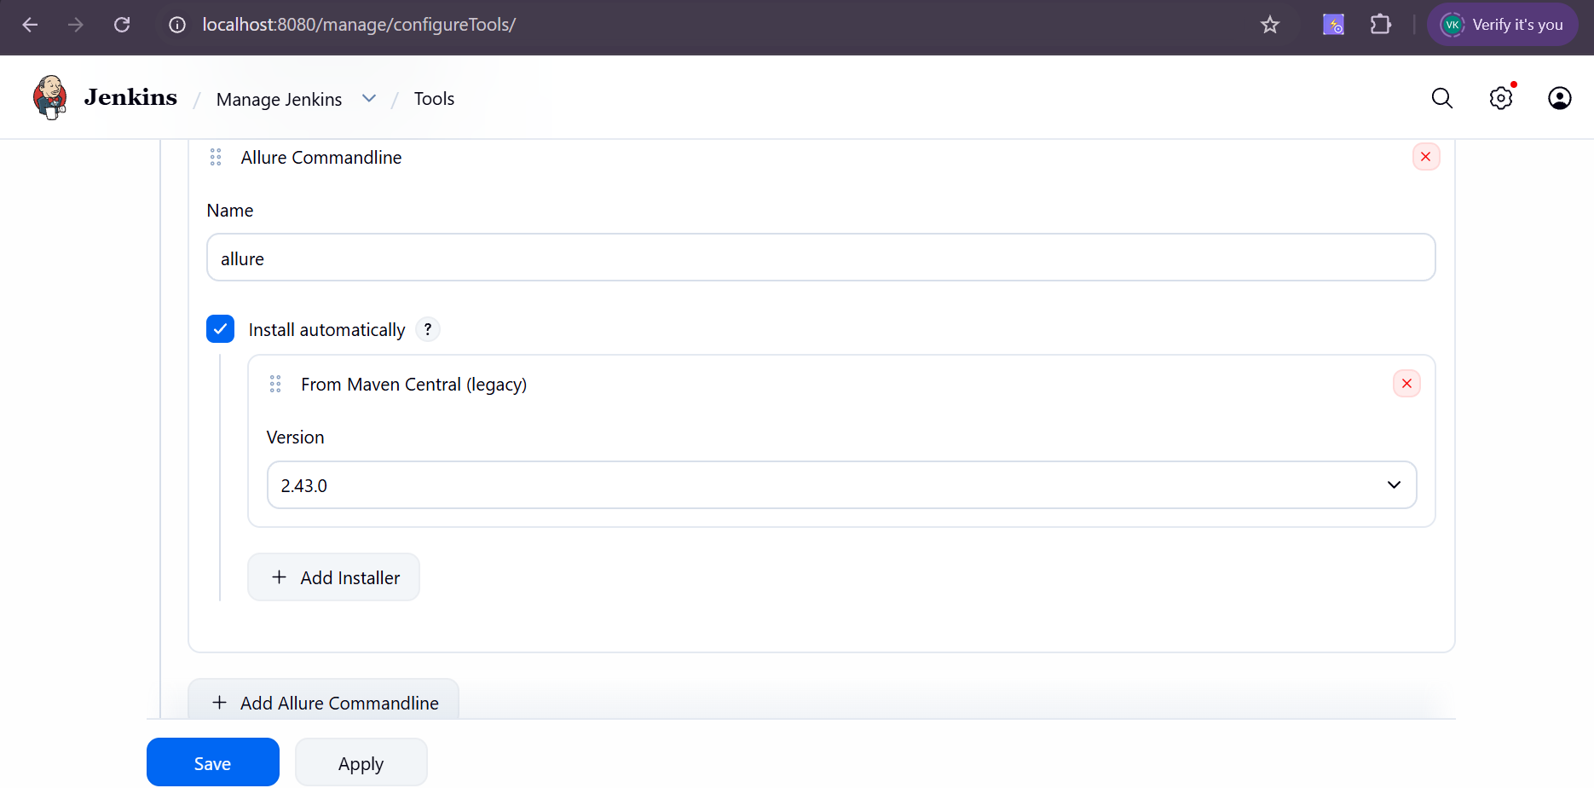

Add Post-build Actions
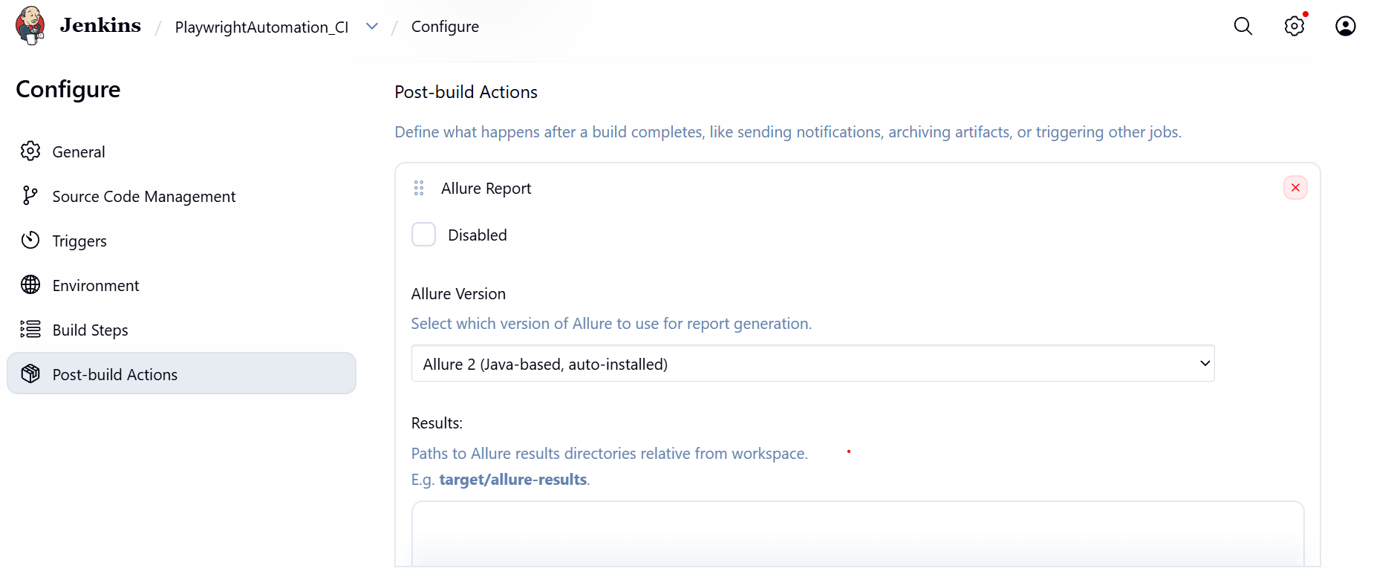
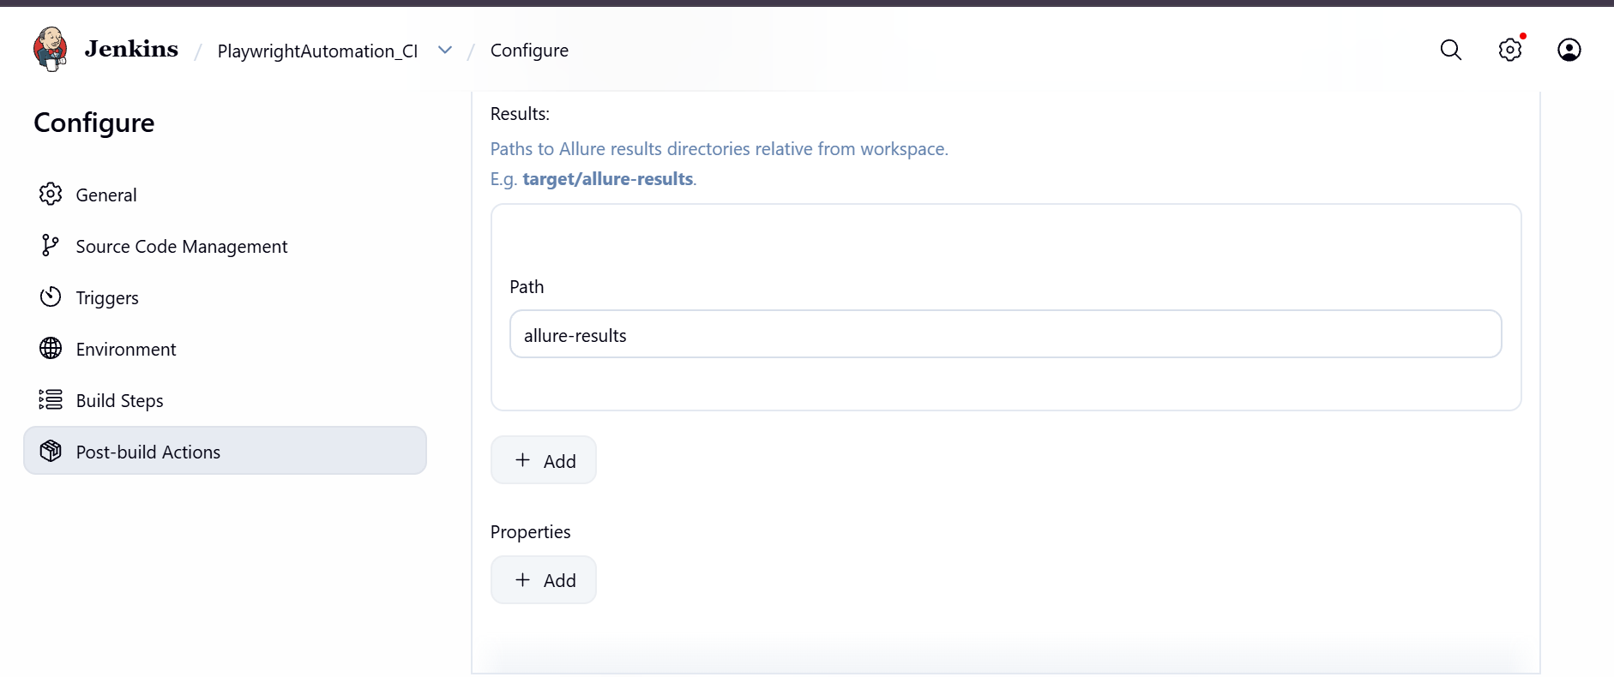

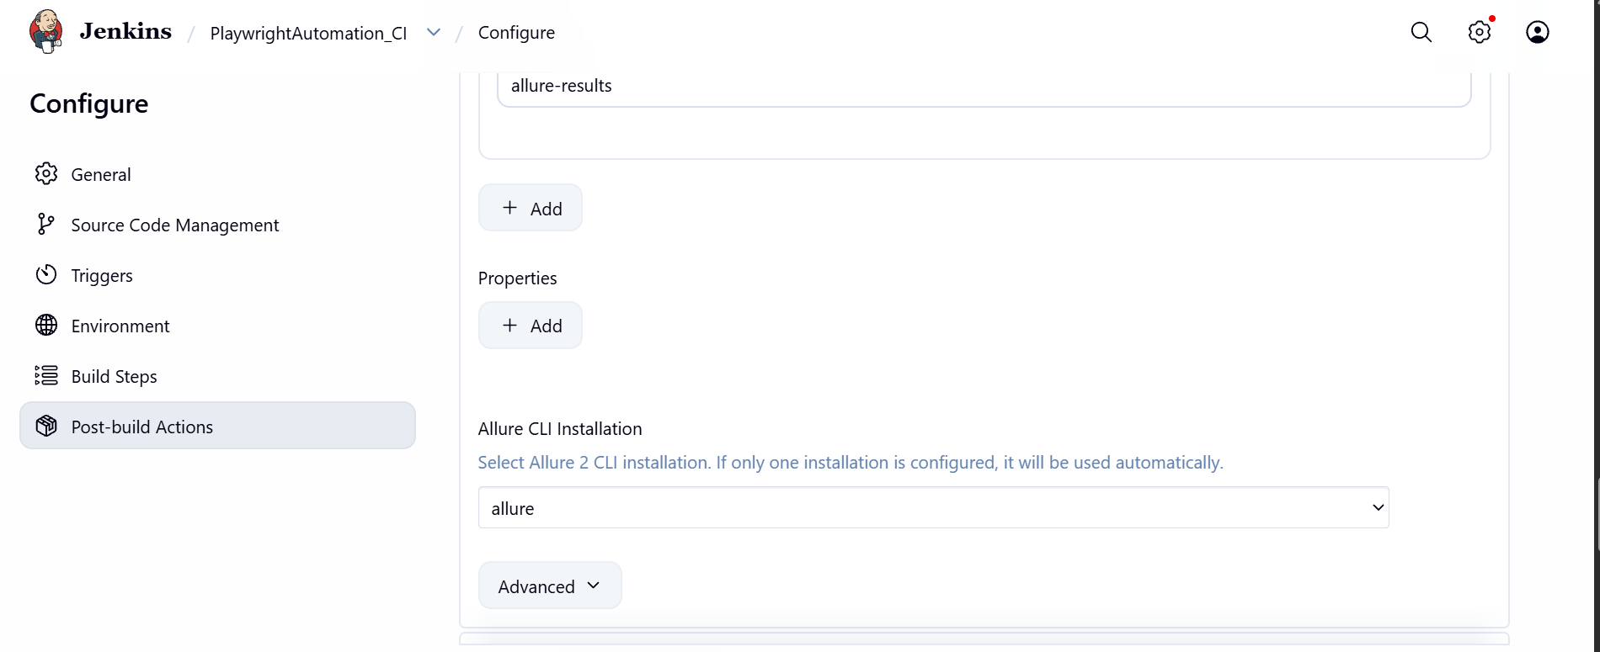

Add packages in project
npm install -D allure-playwright
npm install -D allure-commandline

Add reporting in playwright.config.ts
reporter: [ ['line'],
['html'],
['allure-playwright'] ]

Playwright HTML Report-
Download pluging - HTML publisher
Add Post-build Actions
Select Publish HTML reports
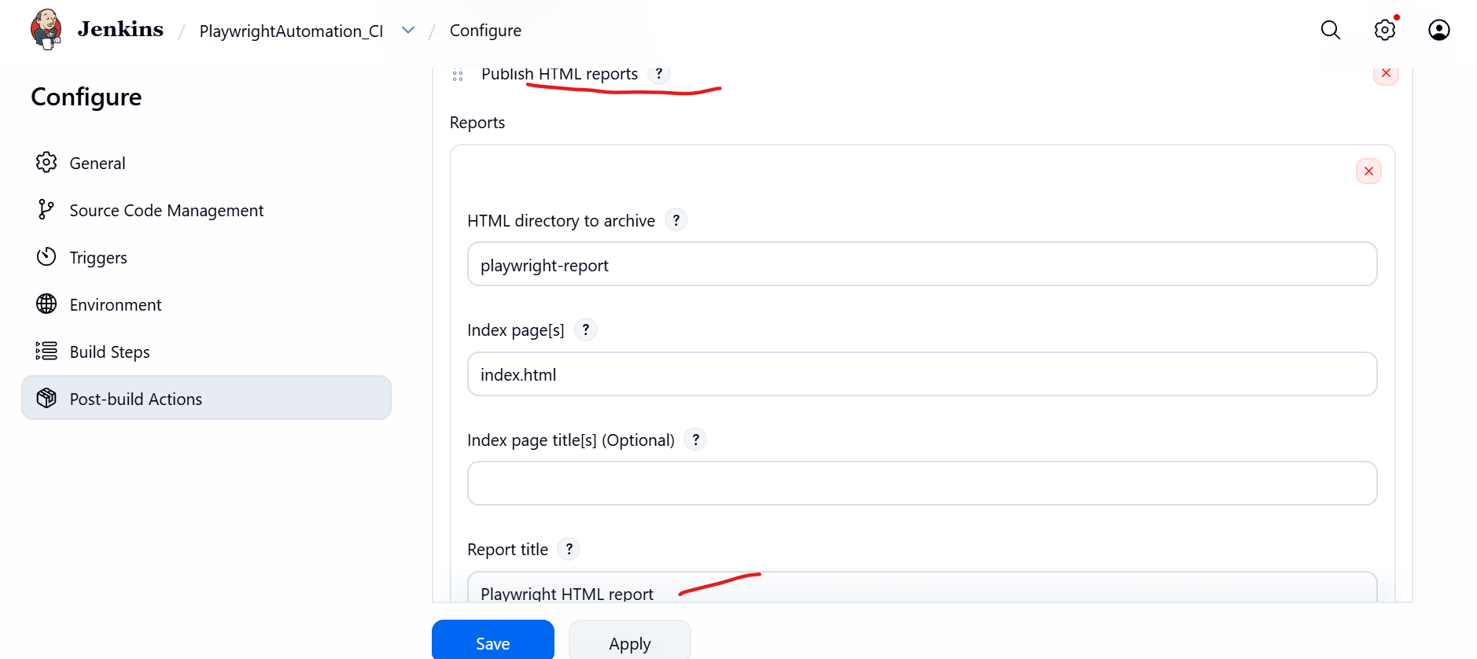

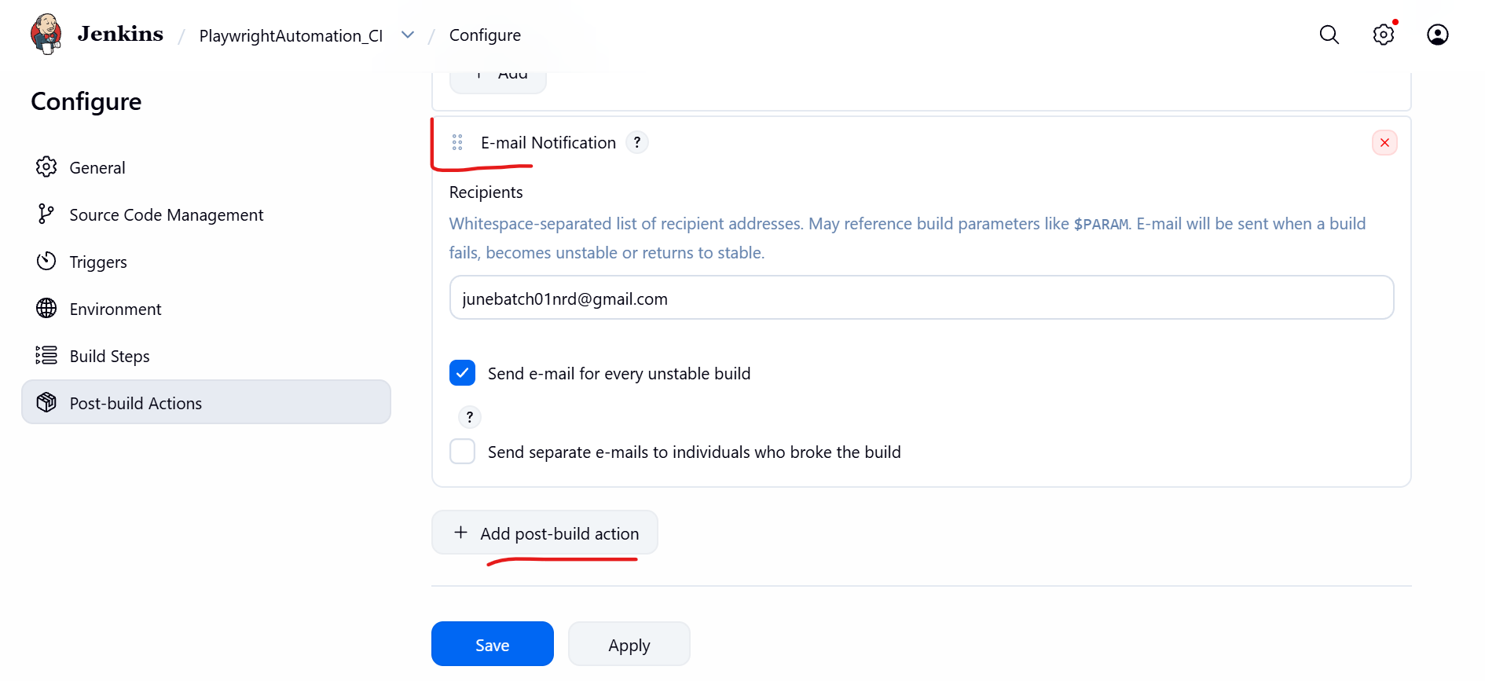

How to resolve blank reports issue in freestyle jenkins project-
Go to Settings-
Script Console
In console add below script and run
println(System.getProperty("hudson.model.DirectoryBrowserSupport.CSP"))
If result is null then run below command -
System.setProperty(
"hudson.model.DirectoryBrowserSupport.CSP",
"sandbox allow-same-origin allow-scripts; default-src 'self'; img-src 'self' data:; style-src 'self' 'unsafe-inline'; script-src 'self' 'unsafe-inline';"
)
You will get the results as -
sandbox allow-same-origin allow-scripts; default-src 'self'; img-src 'self' data:; style-src 'self' 'unsafe-inline'; script-src 'self' 'unsafe-inline';
Then again run
println(System.getProperty("hudson.model.DirectoryBrowserSupport.CSP"))
Validate result with previous result if matching then run the build and check the reports in jenkins.

23. Create Jenkinsfile in project
Jenkinsfile contains automation pipeline steps.
pipeline {
agent any

environment {
CI = 'true'
}

triggers {
// Check GitHub every 2 minutes
pollSCM('H/2 * * * *')
}

options {
timestamps()
timeout(time: 60, unit: 'MINUTES')
}

stages {
stage('Clean Reports') {
steps {
bat '''
IF EXIST allure-results rmdir /S /Q allure-results
IF EXIST allure-report rmdir /S /Q allure-report
IF EXIST playwright-report rmdir /S /Q playwright-report
IF EXIST test-results rmdir /S /Q test-results
'''
}
}

stage('Install Dependencies') {
steps {
bat 'npm install'
}
}

stage('Install Playwright Browsers') {
steps {
bat 'npx playwright install'
}
}

stage('Run Smoke Tests') {
steps {
bat 'npx playwright test --grep "@smoke"'
}
}
}

post {
always {
publishHTML(target: [
reportName: 'Playwright HTML Report',
reportDir: 'playwright-report',
reportFiles: 'index.html',
keepAll: true,
alwaysLinkToLastBuild: true,
allowMissing: true
])

allure([
includeProperties: false,
jdk: '',
results: [[path: 'allure-results']]
])
}

success {
echo '================================='
echo 'Pipeline executed successfully.'
echo '================================='
}

failure {
echo '================================='
echo 'Pipeline execution failed.'
echo 'Check Console Output and Reports.'
echo '================================='
}

cleanup {
cleanWs()
}
}
}

24. Push Jenkinsfile
Push Jenkinsfile into GitHub repository.
- git add .
- git commit -m "Added Jenkinsfile"
- git push origin main

25. Manual Jenkins Trigger
This project uses manual Jenkins trigger only.
- Open Jenkins Job
- Click Build Now
- Open Console Output
- Verify Pipeline Execution

26. Clone Project in Another Machine
Clone repository in another system.
- git clone https://github.com/username/playwright-project.git
- cd playwright-project
- npm install
- npx playwright install
- npx playwright test

27. Real-Time Company Flow
Complete company development flow.
- QA creates feature branch
- QA pushes code
- Pull Request raised
- Code review performed
- Merge into main
- Jenkins manual build triggered
- Automation executed

28. Best Practices
Important points followed in real-time projects.
- Never work directly on main branch
- Always pull latest code
- Write meaningful commit messages
- Use feature branches
- Resolve conflicts carefully
- Keep Jenkinsfile in root folder

29. Summary
This document covered complete GitHub and Jenkins integration flow including installation, repository creation, branching strategy, pull request flow, Git commands, Jenkins setup, and manual pipeline execution.

Jenkins Full Reset — Run these one by one:
Step 1: Stop Jenkins
cmd
net stop Jenkins

Uninstall Jenkins from control panel
Delete Folder
C:\Program Files/Jenkins
Step 2: Delete entire Jenkins data folder
Cmd as administrator
rd /s /q "C:\ProgramData\Jenkins\.jenkins"
Step 3: Restart laptop/pc
Step 4: Wait 30 seconds for Jenkins to fully initialize, then open:
http://localhost:8080
It should now show the Unlock Jenkins screen like this:
Unlock Jenkins
Getting Started...
Please copy the password from one of these locations:
C:\ProgramData\Jenkins\.jenkins\secrets\initialAdminPassword
Step 5: Get the password
cmd
type "C:\ProgramData\Jenkins\.jenkins\secrets\initialAdminPassword"

